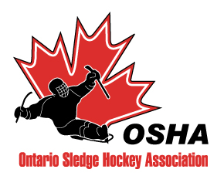

OFFICIAL
PLAYING RULES

Date of Issue: September 2015

ONTARIO SLEDGE HOCKEY ASSOCIATION
OFFICIAL PLAYING RULES

TABLE OF CONTENTS

PAGE
OFFICIAL PLAYING RULES 1
1.0 BASIC RULES 1
2.0 ELIGIBILITY 1
3.0 COMPOSITION OF TEAMS 2
4.0 THE RINK 4
5.0 OFFICIALS AND AUTHORITY 5
6.0 SLEDGES 6
7.0 STICKS 7
8.0 GOAL KEEPER’S EQUIPMENT 8
9.0 PROTECTIVE EQUIPMENT 8
10.0 DANGEROUS EQUIPMENT 9
11.0 PENALTIES SPECIFIC TO SLEDGE HOCKEY 9
12.0 GAME TIMES AND DURATION 14
13.0 TOURNAMENT FORMAT 15

ILLUSTRATION FIGURES 16
1.0 PUSHER RULE 03
Figure #1, Rule 3.5 17
2.0 SLEDGE/PLAYER CHECK PERMITTED RULE 11
Figure #2, Rule 11.11 18
3.0 BODY CHECK PERMITTED RULE 11
Figure #3, Rule 11.12 19
4.0 INTENTIONAL “T-BONING” RULE 11
Figure #4, Rule 11.13 20
5.0 CHECKING FROM BEHIND RULE 11
Figure #5, Rule 11.14 21
6.0 DELAYED OFF-SIDE/CLEAR ZONE RULE 12
Figure #6, Rule 11.28 22
7.0 OFF-SIDE PASS AT BLUE LINE RULE 13
Figure #7, Rule 11.30 23
8.0 Deflector Boards at Players’ Bench(s) 04
Figure # 8, Rule 4.4 24

OFFICIAL PLAYING RULES

BASIC RULES

  - The following O.S.H.A. rules will be used as a complement to the Hockey Canada Rules.

  - Current O.S.H.A. rules will be defined as the rules published to the O.S.H.A. website at the beginning of each season. Updated rules will be distributed to Club representatives when issued. Rules will be clearly labeled with a Reference Number and Date of Issue.

ELIGIBILITY

  - Eligibility for competition is all male and female athletes with a permanent functional and/or sensory disability that would normally preclude an athlete from playing regular competitive hockey. An unlimited number of Able Bodied players are permitted in all divisions of Sledge Hockey.

  - Divisions of players may be established depending on the levels of competition:

JUNIOR DEVELOPMENT SLEDGE HOCKEY LEAGUE

Open to all ages based on skill level. This level is “recreational” and for players who would not dominate with their skills or could not play at a higher level, as they may not physically be able to do so.

Where appropriate, players that have developed their skills and are capable to play at the Intermediate Level, must be moved up to the Intermediate Level of competition.

INTERMEDIATE

Open to all ages, based on athlete’s skill level.

SENIOR – ELITE DIVISION

Open to all ages, based on the athlete’s skill level.
Current National players may play within the OSHA at the Senior-Elite Division only. Teams may only have a maximum of 2 National players on the ice at any one time or be penalized a minor penalty for illegal players.

  - Any player may elect to play sledge hockey at a higher level of competition, but may not revert back to a lower level of competition after playing three (3) or more league or playoff games at the higher level during the same season. Exhibition and tournament games are excluded in the game count towards a player moving up.

  - A player that is on a call-up list for the National Team, may participate in OSHA League play, as long as not being on the permanent roster. The call up games will not affect the 3 game count, as in rule 2.3.

  - Able-bodied players shall be permitted to play the goaltender position at all levels of Sledge Hockey.

  - Players registered with an OSHA member team may be on the roster of only one team at any one time for OSHA games, but may practice with another team(s). A player may join another team for tournament games. The player may return to his/her original team following the tournament. OSHA Player Release forms must be utilized.

  - National team members may revert back to a lower competitive level team within the OSHA once they leave the National Program.

  - No player registered after 11:59 pm January 15th of the current Sledge Hockey season may participate in any remaining regular season games or play-off games. They may practice and play in exhibition and tournament games.

COMPOSITION OF TEAMS

Minimum number of players required to play a game is 4 (3 players plus a goalie or equivalent)

  - Teams will have no maximum number of players, with only 6 players on the ice at one time. (Typically this would be three (3) forwards, two (2) defense and a goaltender). Only a team Coach, Assistant Coach, Manager, Trainer, and Equipment Manager are permitted on the bench during a game. Bench personnel shall be limited to a maximum of five persons. Spectators are not allowed in the bench area. If at any time a goalie is not available or a team wishes not to declare a player to have goaltender privileges then they may opt to have 6 regular skaters i.e. three (3) forwards and three (3) defense or any combination of the above.

A team’s second goalie, as recorded on game sheet, may play ‘out’ when not in net as long as they use two sticks, regular hockey gloves, a regular CSA approved helmet and remove any goalie specific leg wear.

  - The captain and up to three (3) assistant captains must be indicated on the Official Game Sheet. It is recommended that the player’s sweaters also indicate this role either on the front in the typical upper shoulder area or on the back in the upper shoulder area for easy visual reference for the on ice officials.

  - Able bodied players must be recorded as “AB” on the Official Game Sheet.

  - Coaches are NOT permitted on the ice during play unless they are assisting or up -righting players. All coaches MUST wear a properly fastened CSA approved helmet and hockey skates while on the ice and may NOT carry hockey sticks or pushing devices. Coaches do NOT require face guards. On-ice coaching and positioning is only permitted at stoppages of play. For a violation of this rule the bench shall receive one (1) warning for the first offence and receive a bench minor penalty for every subsequent violation of this rule.

  - PUSHERS

An athlete who could not otherwise move a sledge will be allowed to play with a pusher. These players will be able to play in the neutral zone and attacking zone without any space (ice) limitations. Pusher/players are not allowed to play within an area in their defensive zone bounded by the area with lines drawn from the defending goal posts to end face-off spots and out to intersect with the blue line. (See figure # 1)
This allows the player to play within his/her defensive area but out of the slot area for safety and to limit interference of play.
After one (1) warning, a minor penalty will apply for interference.
- The pusher may not intentionally stop or pass the puck with their skates
- The pusher may not skate as fast as a puck carrier
- The pusher may not skate faster than the average speed of the players on the ice of both teams.
- The pusher may not skate backwards with the player – only to turn
- The pusher may not use a hockey stick to push – handles or by hand
- The pusher may not coach other players on the ice while pushing
- The pusher may not dominate or intimidate other players
- The pusher will perform to the skill level of the player being pushed
- The pusher can not overtake any player with the puck

If any infraction of the above is committed, a minor penalty will be assessed to the player and pusher and both will be required to sit in the penalty area.

  - If a player is caught or interfered with by another player either with or without a pusher while that player is on a clear breakaway on the offensive side of the centre red line and a scoring chance has been denied, the offended player will receive a penalty shot. If a scoring opportunity has not been denied a penalty for interference shall still apply to both the player and the pusher. (For the application of this rule the player in possession and control of the puck does not have to be fouled from behind).

  - Pushers MUST wear ice hockey skates, (no figure skates), a CSA approved helmet properly fastened with a full face guard, shin pads, elbow pads, hockey gloves and a numbered matching team sweater or colours. They may choose to wear additional personal protective devices. After one (1) warning by the referee, the pusher will not be allowed to participate in the game until the issue is corrected. If a further violation occurs during the game a minor penalty for ineligible player will apply. For any further offence a minor penalty plus a Misconduct penalty for unsportsmanlike conduct will apply. This penalty will only apply to the pusher and will not affect the player in anyway; however the team would have to sit a player for the minor penalty.

  - Pushers are allowed in Junior/Development and Intermediate. They are not allowed in Senior.

  - A maximum of two (2) pushers for each team on the ice, in play, at any one time unless the team has a variance from the OSHA Rules Committee. A Minor penalty for ineligible player will apply.

  - AFFILIATED PLAYERS:

- To supplement their roster, teams may carry up to 6 affiliated players (APs) from teams not involved in league play (variances must be approved by RULES COMMITTEE)
- APs must be approved (not released) by their home clubs
- APs must be declared in writing to league committee by Oct 15 of current season
- APs should be 'signed' for play with next closest geographic centre where possible
- APs should not cross centres except in cases where middle centre has adequate roster size, does not use or require APs and notice of such is provided by middle centre
- APs are eligible for league, exhibition, tournament, and playoff play
- Teams using the majority of another team’s players as APs, should include all players from the other team. A variance is not required in this case, however, the league must be notified. (E.g. Team A wishes to use Team B players as APs. Team B is not involved in league play and has 8 players. Team A should carry all 8 Team B players)

THE RINK

  - A standard ice hockey rink with standard ice markings and goals shall be used.

  - The referee shall designate to each team a specified area on the ice between the centre line and the blue lines on the playing surface as “bench areas”. Player’s benches may be on the same side as the referee’s semi-circle near the time keeper’s box to avoid interference with the game or frequent stoppages of play.

  - Penalty box areas will be located against the boards on either side of the centre line, in front of the penalty box.

  - “Deflectors Boards” will be mandatory for the 2012-2013 season at each end of the players’ bench areas, located against the side boards, placed 4” (four inches) outside the blue line (in neutral zone and not touching the blue line) so that the puck may leave defensive zone before hitting the deflector.
The Deflector Board is to deflect the puck away from the players’ bench area and allow play to continue.
The dimensions are:
- 20”x 20” x 28” (45° angle) x 5 ½” high.
- 1 ½” thick (2”x 6” material)
The Deflector Board is held to the ice with three (3) nails/pins ¾” long.

(See Figure #8) The long side may be covered with a plastic material same as or similar to the material utilized for the arena boards.

OFFICIALS AND AUTHORITY

  - “On ice” officials MUST be carded through one of the following:

- The National Certification Program for Officials
- Hockey Canada
- Ontario Hockey Federation
- Local Minor Hockey Association
- Ontario Sledge Hockey Association

  - It is required that two (2) “on ice” officials for all regular season sledge hockey games. It is recommended that three, (3), “on ice” officials (one referee and two linesman) are used for all play off, play down and championship games.

  - “On ice” officials have the authority to measure the sledges, sticks and other equipment prior to a game and during if properly requested.

  - It is recommended that the “on ice” officials inspect the sledges or equipment for safety prior to the start of game.

  - Illegal equipment will be removed from the game immediately and the offending team assessed a bench penalty and served by the offending player or player on the ice at the time of infraction. A minor penalty for illegal equipment shall be assessed if this infraction was committed after the start of the game and the penalty will be served by the offending player unless that player was the goalie, (in that case a player on the ice at the time of the infraction will serve the minor penalty). If the illegal equipment is noticed and removed before the start of the game i.e. the drop of the puck, the offending team will not incur a minor penalty and the infraction will be noted on the back of the game sheet with full details of equipment used as well as the player involved. This will then be dealt with by O.S.H.A. The goalkeeper shall not serve any minor penalty. Repeated use of the same or similar illegal equipment will result in a major penalty and game misconduct to the offending player.

  - All coaches must be certified at a Sledge Hockey and/or National Certification Program.

  - Teams should have a certified and carded trainer on the bench for games. In emergency situations, a carded coach who is also certified as a trainer may act as both coach or assistant coach and trainer.

Each trainer for a hockey team will act as the trainer for an opposing team’s players if the trainer for that team must leave his position on the bench or is unable to attend the game. The coach of the team without a trainer should advise the other team’s coach and trainer as well as the referees of the situation. If no trainer is readily available to come to the assistance of an injured player, the game will be suspended. All of these occurrences must be noted on the back of the game sheet with all parties signing and clearing stating responsibilities for those involved.

If the home team cannot provide a trainer for the home or visiting teams – the game would then be suspended and the game forfeited by the home team. This must be noted on the back of the game sheet.

  - Trainer(s) must be Bench Staff and cannot be a player or pusher during the game in which they are acting as a trainer.

  - Teams may have a maximum bench staff of five (5) personnel: head coach, assistant coach(s), trainer(s) and a manager.

SLEDGES

  - The height of the main frame measured from the ice to the bottom of the frame shall be 8.5 - 9.5 cm

  - The length of all runners in contact with the ice must not exceed one third (1/3) of the total length of the sledge.

  - Devices under the sledge (except for runners) are prohibited except for anti-tipping devices.

  - No objects including a hockey stick may be attached to the sides of the sledge. This is considered potentially dangerous and illegal, therefore, must be removed.

  - The puck must be able to roll on edge beneath the sledge, excluding where the runner/blades are attached.

  - The sledge may be equipped with a back rest (chair back), but it must not protrude laterally beyond the armpits of the player when properly seated on the sledge. The back rest may be padded and shall have rounded edges/corners with no hard or sharp obstructions to the sides.

  - No external projection or protuberance beyond the seat or back support towards the rear of the sledge will be allowed in excess of 10 mm

  - All player’s, including the goalie’s feet, ankles, knees and hips must be secured to/in the sledge. If a player continues to fall out of the sledge or feet are on ice continually, one (1) warning and assess minor penalty for illegal equipment.

  - Sledge frames may be constructed of the following approved materials: steel, aluminum, titanium and magnesium. The Material must be cylindrical and not have a diameter smaller than 1.5cm or greater than 3cm.

  - A foot guard/support is required of all sledges and shall be made of the same material as the main frame. The foot guard may vary in height (depending on player’s foot size) but shall be a minimum of 15cm high, not extend outside main frame and may not extend above the players feet/foot. Any deviation must be approved by the OSHA Rules Committee.

STICKS

  - A player’s stick(s) shall not exceed the maximum length of 100 cm, to be measured along the centre line of the stick, and to include the blade and picks.

  - The depth of the teeth on the pick-ends shall not exceed 4 mm. The pick-ends must be fixed to the lower butt end of the stick and may not end in a single, sharp point, but have a least six (6) teeth per stick. Each tooth of a pick shall not be conical or come to a sharp needle-like or piercing point to avoid puncturing type wounds or possible slashes, intentional or accidental. The pick end may be made of any strong material including steel but not to exceed the width of the stick nor be longer than 10.2 cm (4 inches). The pick ends shall not extend beyond 1 cm of the end of the solid portion of the stick.

  - The blades of the stick shall not exceed a height of 7.5 cm, or a length of 35 cm, measured from the toe to the heel. Both the player’s sticks may be equipped with a blade.

  - All edges on the sticks shall be rounded with 3 mm corners.

  - A player may utilize two (2) sticks, with blades, to facilitate stick handling and ambidextrous shooting.

  - The goalkeeper may use two sticks, the second stick must be the dimensions of a regular player’s stick.

  - One of the goalkeeper’s sticks may be equipped with a larger blade. The blade must not exceed 35 cm in length and 11 cm in height or anywhere along the blade be less than 7.62 cm (3 inches). The goal stick shall have a maximum length of 100 cm (including the blade) to be measured along the centre line of the stick. The goalkeeper’s stick may be curved similar to a players’ stick and may have an
additional pick at the base of the blade not exceeding the regular pick projection of 1 cm, at right angles to facilitate movement back and forth in the goal (e.g. push or pull)

  - The handle, shaft and blade of a stick (including goalkeeper’s stick) may be made of wood, plastic or aluminium/titanium but must not have any pockets, projections, netting or other contrivance designed to catch or hold the puck.

GOAL KEEPER’S EQUIPMENT

  - The goalkeeper shall be allowed to use specialized goaltending equipment such as blockers and catchers’ gloves. These shall be allowed to have 4 mm protuberances or picks protrude or affixed to them. The teeth of the picks shall not exceed 4 mm. This arrangement shall be made in substitute of the other stick. (ref. 7.1, 7.2, 7.6, 7.7, 7.8)

  - The goalkeeper’s equipment shall be secured so as not to impede the passage of the puck, rolling on edge, beneath the goalkeeper’s sledge. Goal pads and equipment must be 8.5 – 9.5 cm off the ice. No aprons or items to be fastened to the side of the sledge (dragging).

  - When using two sticks, it is allowable for a goalie to use one blocker and one regular hockey glove for hand protection.

PROTECTIVE EQUIPMENT

It is strongly recommended that all sledge hockey players, particularly the goalkeeper, wear properly fitted full protective safety equipment as defined in accepted hockey rules for able-bodied ice hockey players.

It is recommended that all players, including Goalkeeper, are required to wear Ice Hockey Skate Boots as protection for the foot and ankle area, (based on their disability). Where a skate boot is not appropriate, the feet should be covered with a puncture resistant and/or padded material to avoid injuries.

  - The wearing of a CSA approved hockey helmet with a full cage or mask covering the entire face is mandatory.

  - The wearing of a protective throat collar or bib is mandatory for all players and goalies at all times (must be BNQ approved).

  - The wearing of elbow pads is mandatory.

  - The wearing of shin pads is mandatory.

  - The wearing of protective gloves is mandatory (hockey, ball hockey, lacrosse protective type). Gloves maybe modified for medical reasons by approved variance.

  - The wearing of shoulder pads is mandatory.

  - After one (1) warning by the Referee to remove, add or fix any equipment, a minor penalty shall be assessed to the offending player for illegal equipment. Any subsequent penalties being assessed to the same player will also have the addition of a Misconduct penalty. A player on the ice at the time of the infraction will be required to serve the minor penalty.

  - “Stop sign patches” are strongly recommended but not mandatory, to be worn at all times and be visible on the back top edge of the hockey jersey. (shoulder area) If a player does not display the patch, he or she may participate in the game. NO penalties will be assessed to the player or the team.

  - Jersey colours for league and tournament play are defined as Home - White/Light and Away - Dark. In cases where a team cannot follow rule, the team must advise their opponent at least 48 hours prior to game time. Incidents where a team does not advise opponent must be reported to the league by the home team.

DANGEROUS EQUIPMENT

10.1 The use of pads, protectors or sticks likely to cause injury is prohibited. After one (1) warning to remove or fix, a Minor penalty for dangerous and illegal equipment will be assessed to the offending player and the dangerous equipment will be removed. Any subsequent Minor penalties to the same player for dangerous and illegal equipment will also incur an automatic Game Misconduct penalty. The minor penalty will be served by a player on the ice at the time of the infraction. Helmet Cams are not to be worn nor used on ice at any time, must be removed immediately and both teams warned. Any further use results in a gross game misconduct to any offending player.

PENALTIES SPECIFIC TO SLEDGE HOCKEY

If at any time an infraction of the rules occurs, a Minor or a Major Penalty plus a Game Misconduct penalty will apply. If the action of the offending player or team official was done as a deliberate attempt to injure or deliberate injury a Match penalty must be assessed

  - Any combination of 3 penalties = game ejection
i.e.:
3 minors | = 3 penalties | = game ejection
2 minors + misconduct | = 3 | = game ejection

- Minor Penalty = 2 minute stop/3 minute running
- Bench Penalty = 2 minute stop/3 minute running
- Major Penalty
      - Major Penalty = 5 minute stop/7 minute running
      - Major Penalty = Automatic ejection from game
      - No injury to opposing player = game ejection
      - If injury to opposing player = game ejection + suspension(chart)
- Fighting: Major + game ejection + suspension(see chart)
- Misconduct: 10 minute penalty with immediate substitution
- Game Misconduct: Ejection + suspension(see chart)
- Match Penalty: Major + ejection, suspended until OSHA hearing
- Penalty Shot: If a goal is scored on a penalty shot, no penalized player returns to the ice if the team scored on is shorthanded.

  - Any player receiving penalties before or after the game has started or when teams are off the ice, will be severely dealt with. A full report must be completed on the back of the official game sheet.

  - Any unnecessary or intentional contact after the whistle or end of period may result in penalties being assessed as prescribed in the rules applicable to the infractions committed.

  - Intentional high sticking or cross checking with the stick or using a stick poking action to push an opponent will result in a major penalty + a game ejection + a suspension(see chart). This is regardless of injury.

  - Any deliberate attempt, or deliberate injure to a player, team official or spectator in any manner will see the offending player or team official receive a Match Penalty. A full report will be made on the back of the official game sheet as well as a complete report being submitted to O.S.H.A.

  - Any intentional physical contact with the goalie while inside the goalie crease will see the offending player receive a Major Penalty and Game Ejection Penalty. Any intentional physical contact with the goalie outside the goalie crease will see the offending player receive a Minor or Major Penalty plus Game Ejection Penalty as prescribed under the normal playing rules.

  - If unintentionally carrying the lower pick end of the stick above shoulder height, when in close proximity of an opponent, and if in the Referee’s opinion this action poses a threat to the safety of the opponent, a minor penalty will be assessed for Unsportsmanlike Conduct. Contact is not a factor for this infraction.

  - If intentionally carrying the lower pick end of a stick carelessly above shoulder height when in close proximity of an opponent, and poses a threat to the safety of the opponent, this will result in a Major penalty for high sticking + game ejection + suspension(see chart) and Game Misconduct Penalty for High Sticking. Contact is not a factor for this infraction. This is regardless of injury.

  - Carrying any part of the stick above the shoulder height in close proximity of an opponent and if in the Referee’s opinion, this action poses a threat to the safety of the opponent will the action will result in a Minor penalty for High Sticking.

  - Intentionally turning up the under part of a sledge or turning the blades towards a player, will result in a Major penalty + game ejection. If the action was a deliberate attempt or deliberate injury, a Match Penalty must be assessed.

  - Checking with the sledge at a slight angle is permitted from the side, (See figure #2) providing elbows/arms/sticks are kept low. If not, this may result in a violation of the rules.

  - Body checking is allowed with the upper body and to the side of a player, (See figure #3) providing that the elbows/arms/sticks are kept low. If not, this may result in a violation of the rules.

  - Intentional running into an opponent at a 90 degree angle from the front or side, (T-boning) will result in a minor penalty. If injury results, a major penalty plus a game ejection plus a game misconduct will be assessed. If the action was a deliberate attempt to injure or deliberate injury a Match penalty must be assessed. Officials are reminded that this can be a defensive and/or offensive penalty. (See figure #4)

  - Ramming or checking from behind, intentionally swinging the sledge or raising the nose of a sledge into an opponent will result in a minor penalty. If injury results, a major plus a game ejection plus a game misconduct will be assessed. (See figure #5) If the action was a deliberate attempt to injure or deliberate injury a Match penalty must be assessed. (See figure #5)

  - A goal will not be allowed if an attacking player throws, pushes, bats or kicks the puck directly into the goal or by throwing, pushing, batting or kicking the puck into the goal off of an attacking or defending player. The face-off will take place at the nearest neutral zone face off location.

  - A player may not stick the picks of their stick into the puck to play or to control the puck. Play will be stopped immediately and no penalty called. After one (1) warning, a minor penalty will be assessed for delay of game.

  - a) Players, except goaltenders, may not close their hands on the puck except to catch the puck out of the air and immediately place it on the ice. Play will continue with no penalty.

b) Hand passes are allowed only in a player’s own defensive zone. Both the passing and receiving player must be in the defensive zone. If a hand pass is made in any other zone, play is stopped and no penalty.

  - The handling of the puck directly with the hand is allowed in a player’s own defensive zone. In any other zone, play is stopped with no penalty, and a face off is held in the appropriate zone. A player may not cradle or hold the puck with their fingers, hands, or sledge to keep it away from an opponent. Play shall be stopped and no penalty. After one (1) warning, a minor penalty may be called for delay of game.

  - The puck shall be considered frozen or unplayable by the referee if the puck is out of sight or stays under the goalkeeper’s gloves or equipment or stays under the sledge. The referee shall stop play and hold a face off at the appropriate face off spot. Note: If the goalkeeper has the puck under the sledge and appears to be protecting the puck from the opponent, the referee shall consider this as the puck being covered, then blow the whistle, stop the play to prevent ramming and pushing. This is protection for the goalkeeper.

  - A goalkeeper, unless sprawling with his or her whole body to stop a shot, cannot intentionally lay the side of the sledge down on the ice to block a shot, prior to the puck being shot or released. This is an infraction. Assess a minor penalty for delay of game. The spirit of this rule is not to take away the anticipation of the goalie but to prevent the obvious and intentional act of “spreading” themselves out to cover as much of the net as possible.

  - A minor penalty shall be assessed to any player who throws his/her stick or any part thereof anywhere other than at the puck carrier.

  - A misconduct penalty shall be assessed to any player who deliberately throws a stick or any part thereof or any object, outside the playing area or at a Game Official.

  - A major penalty shall be assessed to any player who deliberately throws his/her stick or any part thereof, or any other object at the puck or puck carrier in any zone, except when such act has been penalized by the awarding of a penalty shot or a goal.

  - When any player of the defending team, including the goalkeeper, deliberately throws his stick or any part thereof, or any other object at the puck or puck carrier in the defending zone the referee shall allow the play to be completed and if a goal is not scored, a penalty shot shall be awarded to the attacking team. If a goal is scored, the penalty shot shall not be awarded.

  - A player or team official who refuses to leave the bench area or playing area after they have been assessed a Game Misconduct penalty shall be suspended indefinitely and until a hearing is held by the OSHA Rules Committee. A full report must be written up on the back of the official game sheet.

  - A bench minor penalty shall be assessed to a team when any player or team official on the bench bangs the boards or the ice surface with a stick or any other object in protest of an official’s ruling. If the player is identified, they will sit the penalty.

  - Players “taking the face-off” shall place the blades of their sticks parallel and opposite to each other, with the bottom or heel of each of the blades, flat on the ice and entirely clear of the spot where the puck is to be dropped. All other players, excluding goalkeepers, must position themselves at least 4.56 m (15 feet) from the face off spot on their own side of the restraining line (hash marks) which are 91.44 cm (3 feet) apart on the outer edge of the circles, or likewise, if the face-off is mid ice. If a violation of this rule occurs, the referee shall order another face-off and the offending teams’ centre ice player is removed for the face-off.

  - A player caught in the attacking zone “offside” may place him/herself back “on side” by exiting the zone or by coming in contact with the blue line with one or both skate blades of their sledge. Clearing the zone or tagging up is in effect. If all players clear the zone, play will continue. The puck must precede all players at all times while entering the attacking zone. (See figure #6)

  - The centre red line is for icing only and not for offside passes.

  - An offside pass shall be called by the front official. The face-off takes place at the origin of the pass. The positioning of the skate blades of the sledge determines the off side If either or both skate blades are in contact with the attacking blue line, the play is not off side. The puck must precede the player(s) into the attacking zone. The centre red line is not used for off side passes. (See figure #7)

  - Automatic icing will be called, when the entire puck has crossed over the attacking red goal line when shot from behind the attacking team’s side of the red centre line.

  - If the puck enters and remains in the bench or penalty area, the “on ice” official shall stop play to avoid players making contact and to eliminate potential injury. If the puck is deflected or pushed out immediately and into the playing surface, the play will continue unless the puck is intentionally directed to gain an advantage.

  - A player may not pick up the puck on the end of their hockey stick blade to control play and to make a move or throw the puck. Stop play immediately. No penalty. After one (1) warning, a minor penalty to be assessed for unsportsmanlike conduct.

  - A goalie will be assessed a minor penalty for delaying the game, if they have caused a stoppage of play by freezing the puck while all of their body and equipment is completely outside of the goal crease, provided that the goalie has not been pushed out of the crease and/or is not in process of making or completing a save.

  - If a player that is not in control of the puck sledges in front of a player in control with the puck and causes a “T bone” situation, the puck carrier should not be assessed a penalty. The “T bone” penalty is called for the intent of “T boning” a player.

  - A defending or attacking player that interferes a player not in control of the puck will be assessed a minor penalty for interference.

  - A goalie may be replaced with an extra player:
During any stoppage of play
During play – sledge to bench by self, or pushed by pusher/coach/player
Once a goalie has been pulled for an extra player, she/he may return to goal:
During stoppage of play – sledges on own or pushed
During play – must sledge on own and cannot be pushed

The rule “Too many players on the ice” during “changing on the fly” still applies in the above options for change of goalie.
11.38 HEAD CONTACT “NEW” (HOCKEY CANADA RULE 6.5)
STRICTLY ENFORCED – ZERO TOLERANCE

(a) A minor penalty shall be assessed to any player who accidentally contacts an opponent in the head, face or neck with a stick or any part of the player’s body or equipment.
(b) A double minor penalty or a major and a game ejection + suspension (see chart), at the discretion of the referee and based on the degree of violence of impact shall be assessed to any player who intentionally contacts an opponent in the head, face or neck with a stick or any part of the player’s body or equipment.
(c) A major and a game ejection + suspension (see chart) penalty, or match penalty shall be assessed any player who injures an opponent under this rule.
(d) A match penalty shall be assessed any player who deliberately attempts to injure or deliberately injures an opponent under this rule.

Note: All contact above the shoulders (neck, face and head) is to be called Head Contact under one of the above.

11.39 In the Junior Development Sledge Hockey League any intentional body check would be assessed as a minor penalty and any un-intentional contact would not be penalized. If injury results, a major + game ejection + suspension (see chart) would be assessed.

GAME TIMES AND DURATION

  - Length of Game

Junior Development Sledge Hockey League games may be maximum (3) three 15 minute stop time periods (if time permits). Intermediate games may be maximum (3) three 15-minute stop time periods (if time permits). Depending on length of ice time, teams will agree upon the length of periods prior to the game and have times marked appropriately on the Official Game Sheet. Unforeseen circumstances may cause to reduce the length of the game (ie: injuries, power outage, slow game pace etc.). The time of a game may be shortened in accordance with the following schedule. You may refer to the chart below for ideas to shorten the game.

Ice Time  Available | Warm Up | 1st  Period | Rest | 2nd  Period | Rest | 3rd Period
60 | 5 | 10 |  | 10 |  | 10
70 | 5 | 10 |  | 10 |  | 15
1:20 | 5 | 10 |  | 15 |  | 15
1:45 | 5 | 15 |  | 15 | 10 | 15
2:00 | 5 | 15 |  | 15 | 10 | 20
2:15 | 5 | 15 |  | 20 | 10 | 20
2:25 | 5 | 20 | 10 | 20 | 10 | 20
2;40 | 10 | 20 | 10 | 20 | 10 | 20

  - Teams and officials should arrive 30-45 minutes before the start of a scheduled game.

  - The Official time keeper shall operate the game clock. All goals, assists and penalties will be recorded on the official game sheet. A copy of the official game sheet will be distributed to each team as well as a copy being sent to the Ontario Sledge Hockey Association by the home team.

  - Teams should contact the home team a week in advance to confirm game time and location.

  - Teams should contact and notify the home team of severe winter weather, as to their arrival for game time. This should be done 48 hours pre-game time and stay in contact until game day.

  - “On ice” officials, coaches and trainers must record their National Certification Program number on the Official Game Sheet.

  - Regular season games when tied at end of the 3rd period, remain a tied game. Tie breaking rules for league playoff – time permitting. One 5 minute sudden victory period (4 player incl. goalie) followed by three player shootout. Where time does not permit an OT period, go straight to shootout.

  - FORFEITURE POLICY

- Team forfeits a game if they do not show for a game or show without the minimum number of players
- In all cases, winning points awarded to non-forfeiting team
- Forfeitures must be reported to League Committee by the non-forfeiting team as soon as possible
- 48 hour notice should be given by a team unable to show for a game, if less than 48 hours given – except for exceptional circumstances, forfeiting team must pay referee and timekeeper costs to opposing team regardless if paid or not
- Non-forfeiting team is not required to agree to rescheduling the game
- 2nd forfeiture by a team, in a given season, will result in automatic loss of ability to host playoff game that year
- Forfeiture of 50% of a team’s league games, in a given season, will result in loss of league play the following year

TOURNAMENT FORMAT

  - Tournament rules pertaining to format, including scoring and tie breaking, to be determined by the Tournament Host and sanctioned by the OSHA.

ILLUSTRATION FIGURES

OFFICIAL PLAYING RULES 1
ILLUSTRATION FIGURES 16
1.0 PUSHER RULE 03
Figure #1, Rule 3.5 17
2.0 SLEDGE/PLAYER CHECK PERMITTED RULE 11
Figure #2, Rule 11.11 18
3.0 BODY CHECK PERMITTED RULE 11
Figure #3, Rule 11.12 19
4.0 INTENTIONAL “T-BONING” RULE 11
Figure #4, Rule 11.13 20
5.0 CHECKING FROM BEHIND RULE 11
Figure #5, Rule 11.14 21
6.0 DELAYED OFF-SIDE/CLEAR ZONE RULE 12
Figure #6, Rule 11.28 22
7.0 OFF-SIDE PASS AT BLUE LINE RULE 13
Figure #7, Rule 11.30 23
8.0 Deflector Boards at Players’ Bench(s)RULE 05
Figure # 8, Rule 4.4 24

- PUSHER RULE
Figure #1, Rule 3.5
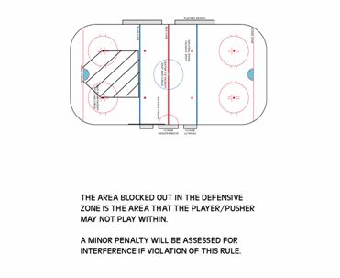

- SLEDGE/PLAYER CHECK PERMITTED RULE
Figure #2, Rule 11.11
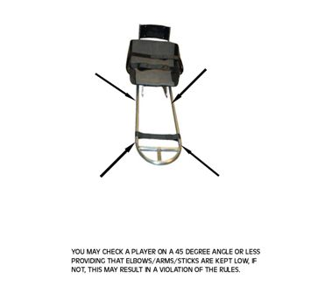

- BODY CHECK PERMITTED RULE
Figure #3, Rule 11.12
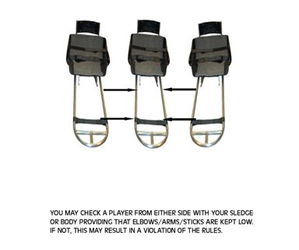

- INTENTIONAL “T-BONING” RULE
Figure #4, Rule 11.13
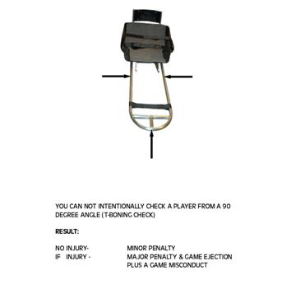

- CHECKING FROM BEHIND RULE
Figure #5, Rule 11.14
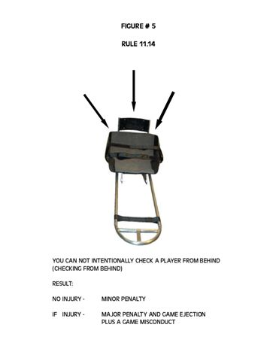
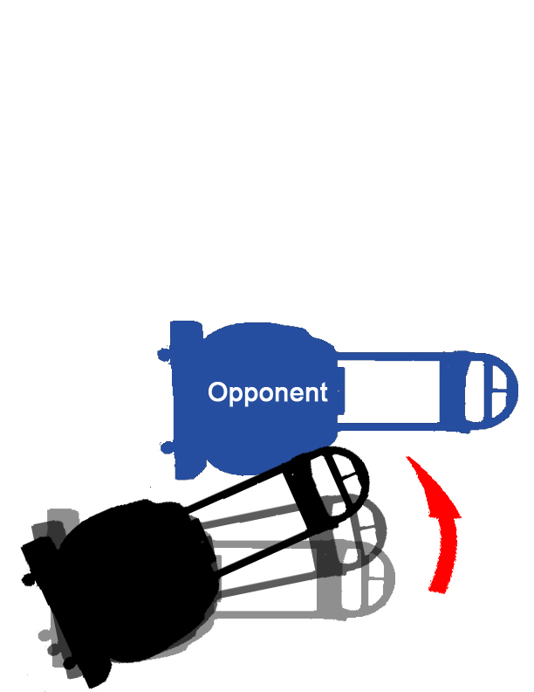
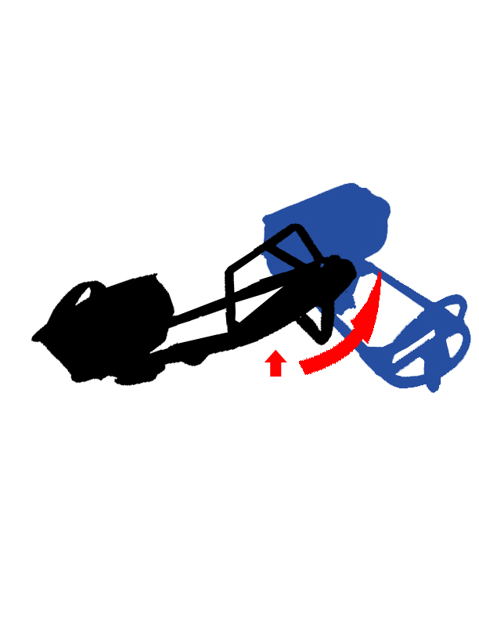
A)
B)
C)
NO
Ramming or checking from behind
B.Intentionally swinging the sledge
C.Raising the nose of a sledge into an opponent

RESULT
Minor penalty
If injury results, a major plus a game ejection plus a game misconduct will be assessed.

- DELAYED OFF-SIDE/CLEAR ZONE RULE
Figure #6, Rule 11.28
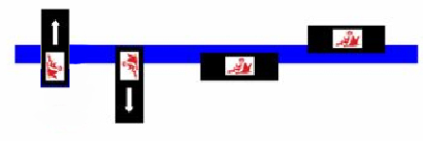
A player caught in the attacking zone “offside” may place him/herself back “on side” by exiting the zone or by coming in contact with the blue line with one or both skate blades of their sledge. Clearing the zone or tagging up is in effect. If all players clear the zone, play will continue. The puck must precede all players at all times while entering the attacking zone.

- OFF-SIDE PASS AT BLUE LINE RULE
Figure #7, Rule 11.30

- Deflector Boards at Players’ Bench(s)
Figure # 8, Rule 4.4

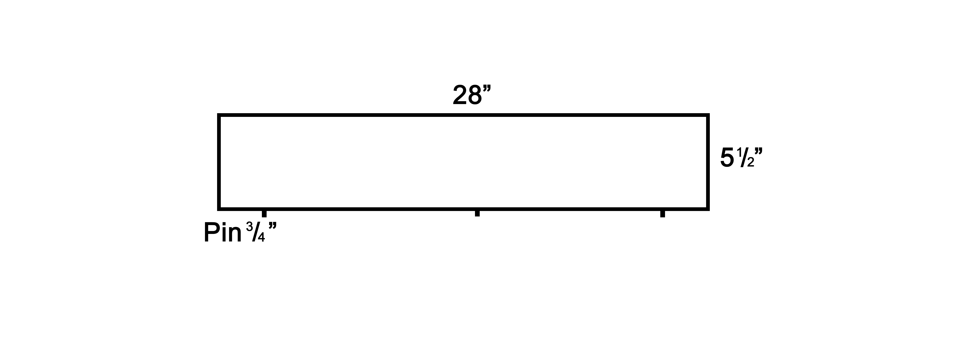
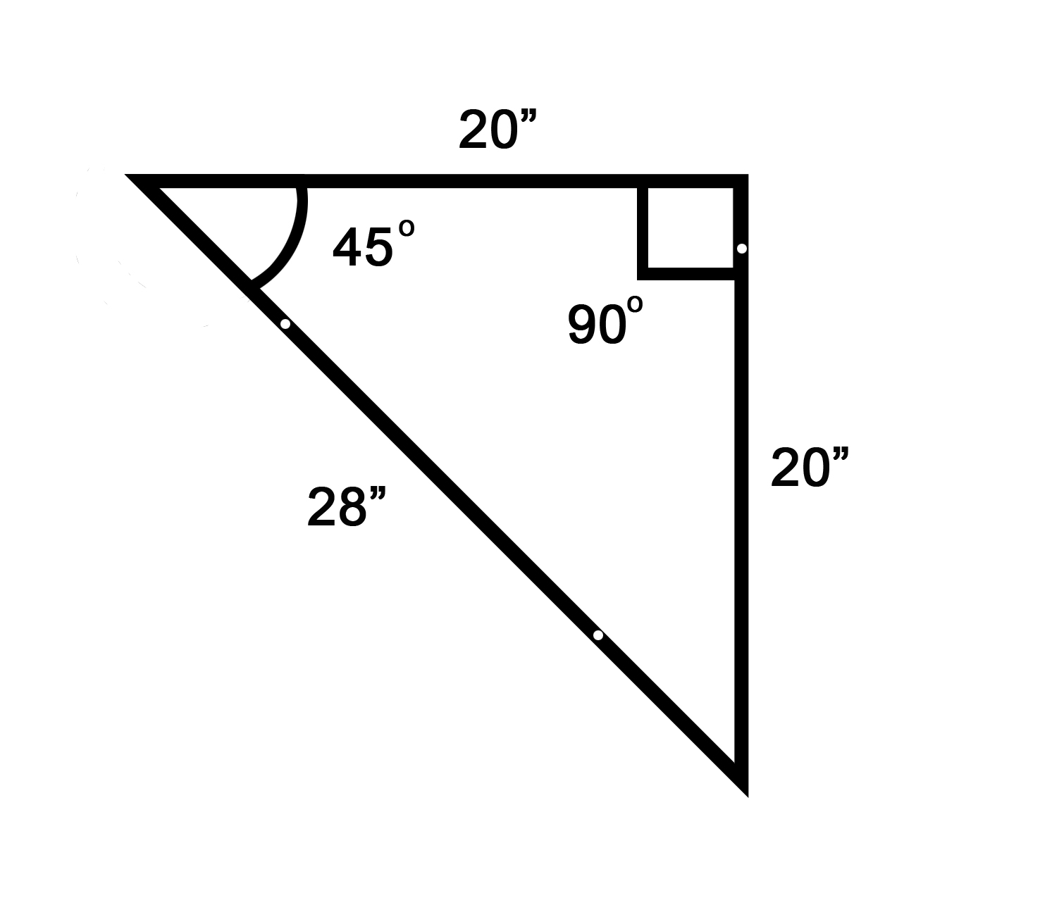
Top View
Side View
Rink Layout
4” (four inches)
Player Seating Area

